Supplemental Material: Age-Period-Cohort Trends in Biological Aging in the U.S. population, 1999-2018

Table of Contents

Methods Supplement: Development of Biological Aging Measures 4

Results Supplement A: Graphical Analysis and Model Comparison 7

**Supplemental Table A1.** Number of participants by age and measurement period, full sample 7

**Supplemental Table A2**. Number of participants by age and measurement period, White Men 7

**Supplemental Table A3.** Number of participants by age and measurement period, White Women 8

**Supplemental Table A4.** Number of participants by age and measurement period, Black Men 8

**Supplemental Table A5.** Number of participants by age and measurement period, Black Women 9

**Supplemental Table A6.** Comparison of one-, two-, and three-factor APC models 9

**Supplemental Figure A1.** Unstratified one-dimensional age, period, and cohort effects 10

**Supplemental Figure A2.** Stratified one-dimensional age, period, and cohort effects 11

**Supplemental Figure A3.** Two-dimensional age by period effects 12

**Supplemental Figure A4.** Two-dimensional age by cohort effects 13

**Supplemental Figure A5.** PhenoAge advancement in among Black Americans and White Americans in the United States, NHANES III and continuous NHANES (1991-2018). 14

Results Supplement B: APC Model Outputs – Sensitivity Analyses 15

**Supplemental Figure B1.** Intrinsic Estimator approach to APC decomposition 16

**Supplemental Figure B2.** Median Polish approach to APC decomposition 17

**Supplemental Figure B3.** Bayesian Hierarchical Age-Period-Cohort models treating age as a factor variable 18

**Supplemental Figure B4.** Bayesian Hierarchical Age-Period-Cohort models using Homeostatic Dysregulation measure of biological aging 19

**Supplemental Figure B5.** Bayesian Hierarchical Age-Period-Cohort models using PhenoAge-advancement measure based on original Levine biomarkers 20

**Supplemental Figure B6.** Bayesian Hierarchical Age-Period-Cohort models using PhenoAge-advancement measure calculated using the residualized-change score method 21

**Supplemental Table B1.** Intrinsic Estimator approach to APC decomposition 22

**Supplemental Table B2.** Median Polish approach to APC decomposition 23

**Supplemental Table B3.** Bayesian Hierarchical Age-Period-Cohort models treating age as a factor variable 24

**Supplemental Table B4.** Bayesian Hierarchical Age-Period-Cohort models using Homeostatic Dysregulation measure of biological aging 25

**Supplemental Table B5.** Bayesian Hierarchical Age-Period-Cohort models using PhenoAge-advancement measure based on original Levine biomarkers 26

**Supplemental Table B6.** Bayesian Hierarchical Age-Period-Cohort models using PhenoAge-advancement measure calculated using the residualized-change score method 27

## Methods Supplement: Development of Biological Aging Measures

Biological aging is a construct first introduced by the fields of geroscience and aging biology, and describes the accumulation of physiological damage across multiple body systems that occurs with advancing chronological ag, mediating aging-related disease and disability (1,2). While there is no gold standard of biological aging (3,4), the most widely-adopted measures to date use machine learning methods to integrate information across multiple clinical parameters collected from blood-chemistry and DNA-methylation data (3–7). Machine-learning methods are used to train these parameters on some aging-related outcome (e.g., chronological age, mortality risk, longitudinal rate of physiological decline) in a reference sample, after which they can be applied as outcome variables in new datasets to test hypotheses.

A conceptual flow diagram of biological-aging algorithm development is shown below:

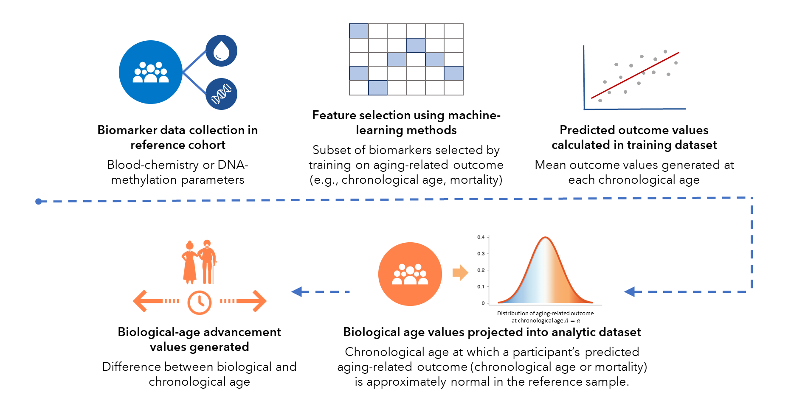

The primary measure of biological aging used in this analysis was biological-age advancement, as measured using the blood-chemistry PhenoAge algorithm (8). Following this method, predicted biological age values represent the age at which a participant’s physiology-predicted mortality risk would be approximately normal in the reference sample in whom the data were originally trained. We conducted comparative analysis using an alternative measure of biological aging, Homeostatic Dysregulation (9). Rather than training biomarkers on mortality prediction, as with the PhenoAge method, the Homeostatic Dysregulation measure quantifies an individual’s deviation (as measured using Mahalanobis distance) from the biomarker profile of a young, healthy reference cohort. Consistency of findings across algorithms trained using different target outcomes and methodological strategies can help to build confidence in study findings.

Our training dataset was composed of all NHANES III participants who provided blood samples during the MEC exam. We first defined the universe of available biomarkers collected in NHANES III and all waves of continuous NHANES, 1999-2018 (**next page, top**). There were 24 unique biomarkers (with 33 total biomarkers based on variable transformations) available in all waves of the continuous NHANES (1999-2018). 21 of these unique biomarkers were also available in the NHANES III training sample: albumin, alkaline phosphatase, blood urea nitrogen, creatinine, glucose, total bilirubin, uric acid, lymphocyte percentage, mean cell volume, monocyte count, red blood cell count, red cell distribution width, white blood cell count, diastolic blood pressure, systolic blood pressure, mean blood pressure, pulse, HbA1c, HDL cholesterol, total cholesterol, and number of hours since last ate or drank:

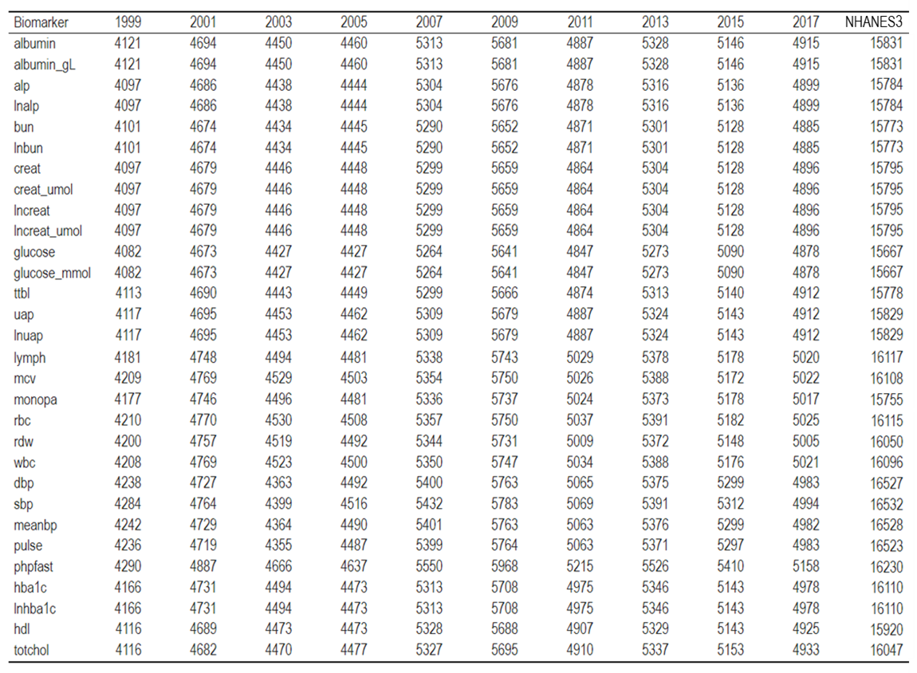

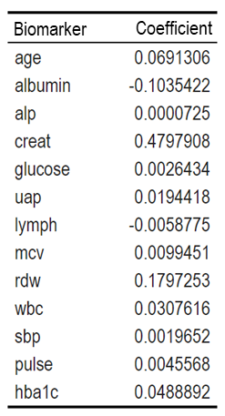To select a subset of biomarkers for use in the PhenoAge algorithm, we used elastic net regression of all candidate biomarkers and chronological age on mortality, consistent with the method as introduced by Levine and colleagues. The 12 biomarkers selected were as follows: albumin, alkaline phosphatase, creatinine, glucose, uric acid, lymphocyte percentage, mean cell volume, red cell distribution width, white blood cell count, systolic blood pressure, pulse, and HbA1c. Coefficients from Cox regressions with elastic net regularization are shown in the table (**right**).

With this set of biomarkers, 14,805 NHANES III participants were included in the training sample and 45370 continuous NHANES participants in the projection sample. PhenoAge and Homeostatic Dysregulation values were trained in the NHANES III sample and then projected into the analytic sample of continuous NHANES participants using the *BioAge* package (10) in the RStudio Integrated Development Environment (IDE) v2023.06.0.421 (11). Biological-age advancement was defined as the difference between PhenoAge and chronological age; Homeostatic Dysregulation values represent Mahalanobis distance from the reference cohort. Both PhenoAge advancement and Homeostatic Dysregulation were significantly associated with mortality in both the NHANES III training sample and the continuous NHANES projection sample (for PhenoAge advancement: HR=1.65 in NHANES III, HR=1.74 in continuous NHANES; for Homeostatic Dysregulation: HR=1.69 in NHANES III, HR=1.90 in continuous NHANES; all effect-sizes are denominated in standard-deviation units and are significant at p<0.001).

Pearson’s r correlations between chronological age, PhenoAge, PhenoAge advancement, and Homeostatic Dysregulation in the continuous NHANES analytic sample are shown below. Chronological age was strongly correlated with PhenoAge (r=0.96), a biological aging algorithm which provides an analog to chronological age indexed to mortality risk, and moderately correlated with Homeostatic Dysregulation (r=0.22). Chronological age was very weakly correlated with PhenoAge advancement (r=0.08), indicating that effects observed in our primary analyses were unlikely to be the artefact of changes in the chronological-age distribution of the population over the study period:

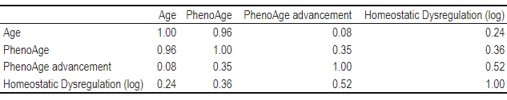

Corresponding Spearman’s rank correlations between chronological age, PhenoAge, PhenoAge advancement, and Homeostatic Dysregulation in the continuous NHANES analytic sample are shown below. Results are consistent with Pearson’s correlations, with even weaker correlations between chronological age and biological-age advancements.

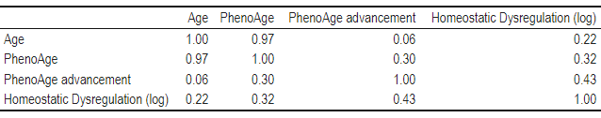

## Results Supplement A: Graphical Analysis and Model Comparison

### **Supplemental Table A1.** Number of participants by age and measurement period, full sample

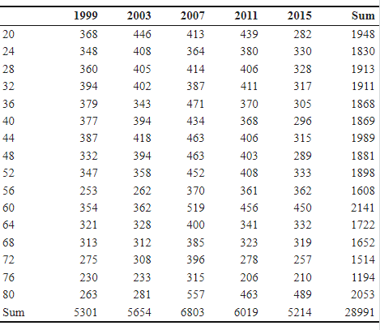

### **Supplemental Table A2**. Number of participants by age and measurement period, White Men

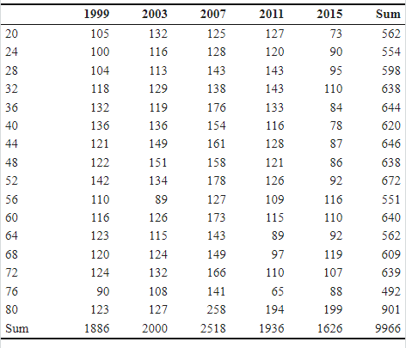

### **Supplemental Table A3.** Number of participants by age and measurement period, White Women

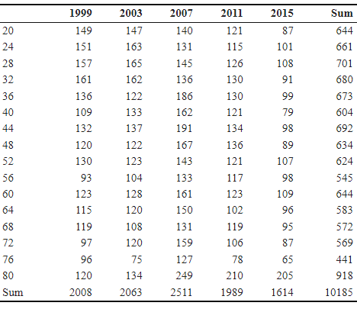

### **Supplemental Table A4.** Number of participants by age and measurement period, Black Men

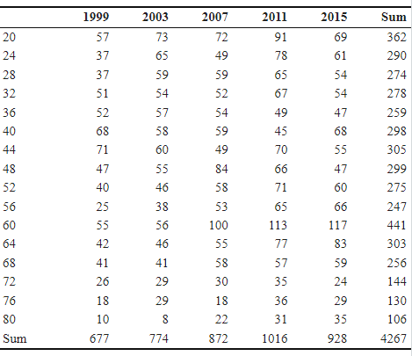

### **Supplemental Table A5.** Number of participants by age and measurement period, Black Women

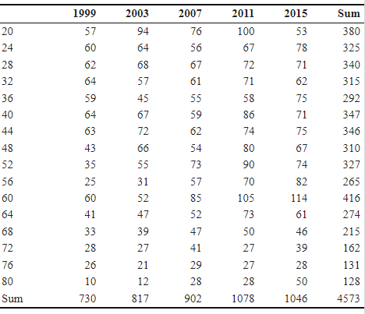

### **Supplemental Table A6.** Comparison of one-, two-, and three-factor APC models

Formal comparison of one-, two-, and three-factor models was performed according to the method specified by Yang and Land (2013). One- and two-factor models were fitted using survey-weighted generalized linear models. The fully specified three-factor model was fitted using a multilevel model, treating age as a level-1 fixed effect and period and cohort as level-2 random effects; survey weights were log-transformed and included as a level-1 covariate while sampling strata and clusters were included as random effects. Comparison of the Akaike information criterion (AIC) indicates that the two-factor (AP) model and fully-specified three-factor model appeared to have comparable model fit. We fitted fully specified three-factor models to explore evidence for the presence of cohort effects and evaluate differences by race and sex.

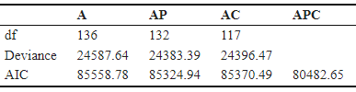

### **Supplemental Figure A1.** Unstratified one-dimensional age, period, and cohort effects

The figure plots survey-weighted mean biological-age advancement among Black Americans and White Americans (1999-2018) over dimensions of age, period, and birth cohort.

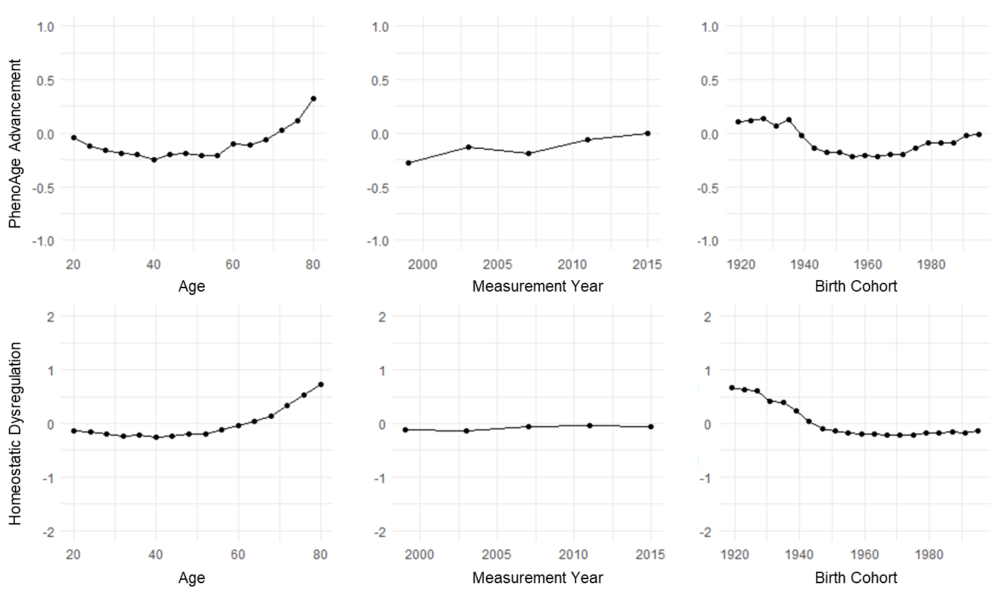

### **Supplemental Figure A2.** Stratified one-dimensional age, period, and cohort effects

The figure plots survey-weighted mean biological-age advancement among Black Americans and White Americans (1999-2018) stratified by race and sex, over dimensions of age, period, and birth cohort.

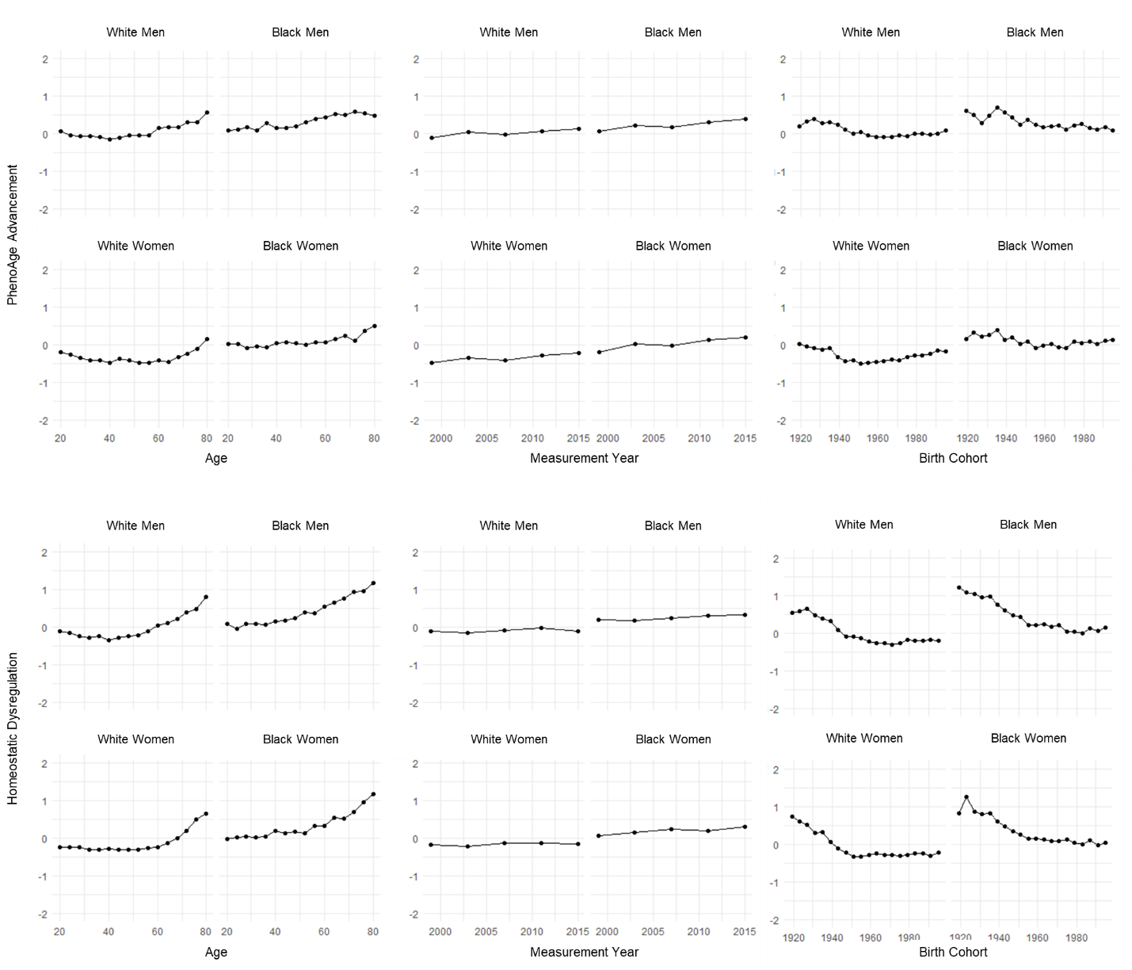

### **Supplemental Figure A3.** Two-dimensional age by period effects

The figure plots survey-weighted mean biological-age advancement among Black Americans and White Americans (1999-2018) by four-year age category, stratified by period (measurement wave).

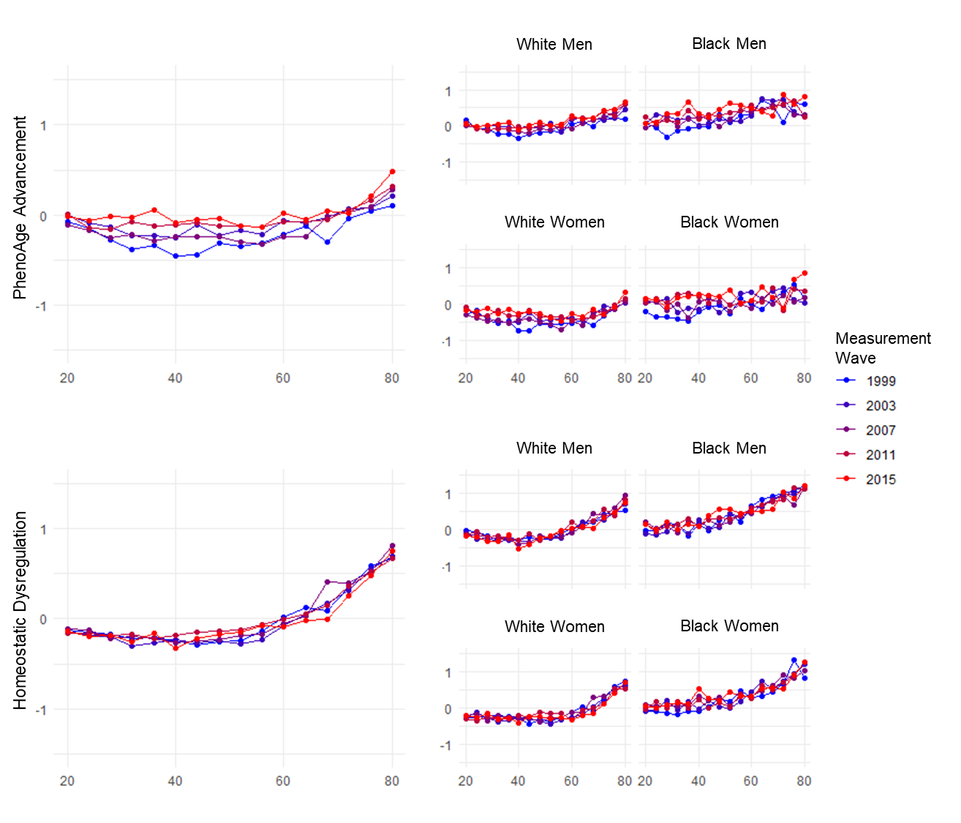

### **Supplemental Figure A4.** Two-dimensional age by cohort effects

The figure plots survey-weighted mean biological-age advancement among Black Americans and White Americans (1999-2018) by four-year age category, stratified by birth cohort.

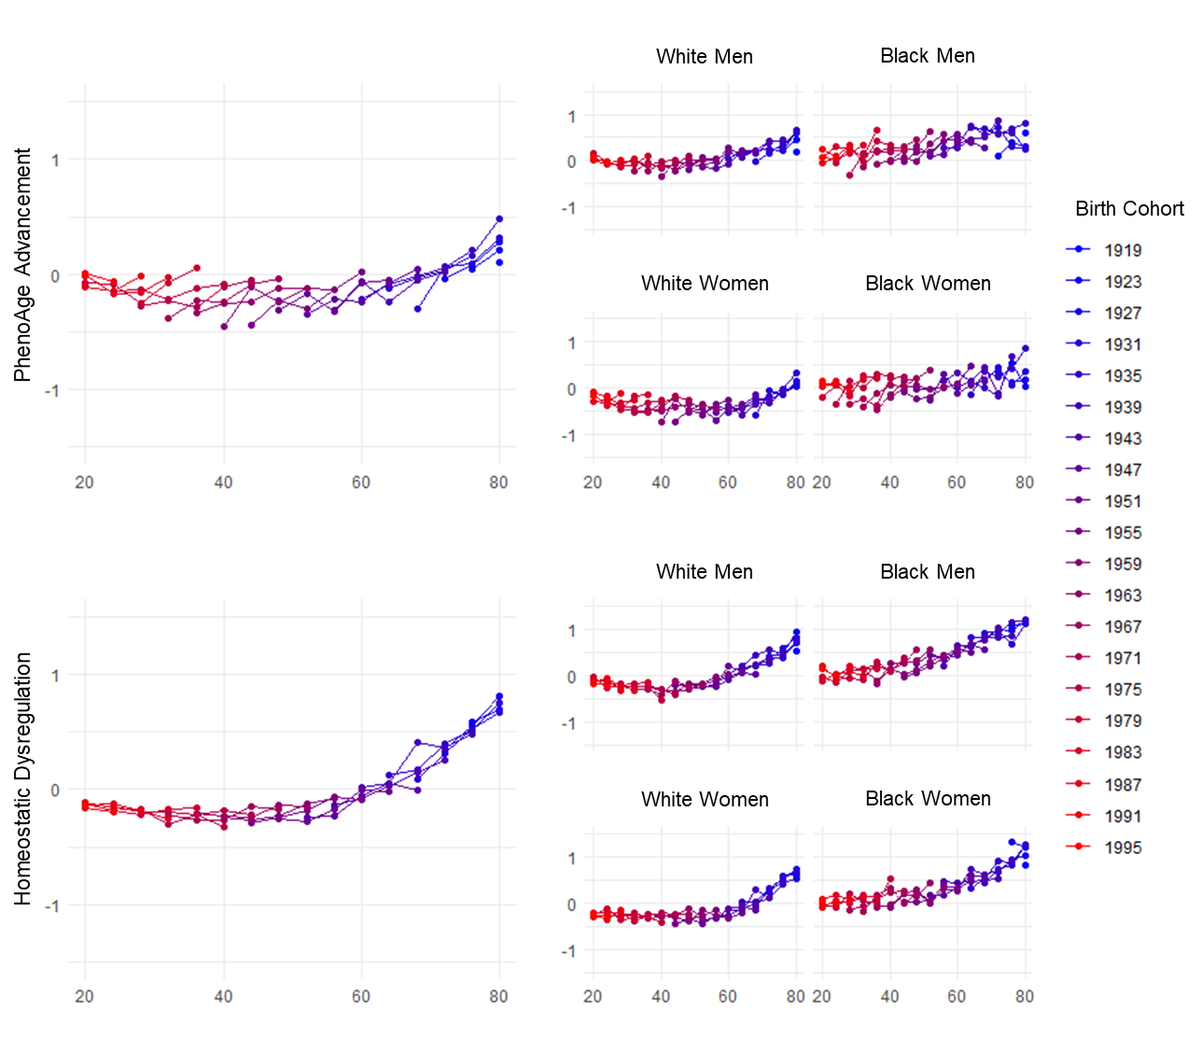

### **Supplemental Figure A5.** PhenoAge advancement in among Black Americans and White Americans in the United States, NHANES III and continuous NHANES (1991-2018).

The figure shows mean biological-age advancements (measured using the Homeostatic Dysregulation algorithm), sample-weighted to the U.S. population at the time of measurement. Less-advanced biological aging values indicate that participants are physiologically younger, while more-advanced biological aging values indicate that participants are physiologically older. Population aging trajectories appeared to increase in the entire population from 1990 to 1999, with continued increases among Black Americans and levelling off among White Americans thereafter.

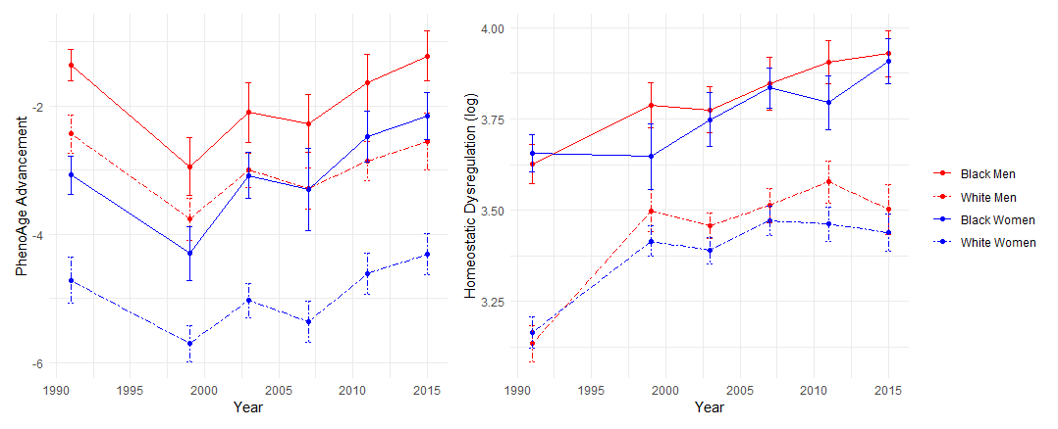

## Results Supplement B: APC Model Outputs – Sensitivity Analyses

Our approach to age-period-cohort (APC) analysis is fully detailed in the Methods section of the manuscript. Briefly, our primary analysis was conducted using Bayesian Hierarchical Age-Period-Cohort models, and with PhenoAge advancement (with biomarkers selected using elastic net regression on mortality) as the outcome measure of biological aging.

We tested the sensitivity of our results to 1) changes in specification of the biological aging outcome variable, and 2) changes in APC model specification. Results of these sensitivity analyses are presented here, in the following order:

1. Change in APC modelling technique, using Intrinsic Estimator instead of Bayesian Hierarchical APC model **(Supplemental Figure and Table B1)**
2. Change in APC modelling technique, using Median Polish approach instead of Bayesian Hierarchical APC model **(Supplemental Figure and Table B2)**
3. Change in specification of original Bayesian HAPC model, specifying age as a 4-year factor rather than a continuous variable **(Supplemental Figure and Table B3)**
4. Change in specification of outcome variable: using Homeostatic Dysregulation instead of PhenoAge advancement **(Supplemental Figure and Table B4)**
5. Change in specification of outcome variable: using a measure of PhenoAge advancement trained on the original biomarkers in Levine et al. 2019, instead of the primary measure of PhenoAge advancement trained on elastic net regression on mortality **(Supplemental Figure and Table B5)**
6. Change in specification of outcome variable: using PhenoAge advancement values calculated using residualized-change scores instead of raw differences with chronological age **(Supplemental Figure and Table B6)**

### **Supplemental Figure B1.** Intrinsic Estimator approach to APC decomposition

The figure shows the independent effects of age, period, and cohort as estimated using the Intrinsic Estimator (IE) method, both in the full sample and separately by race-sex strata. Survey weights were applied in estimating mean biological aging values for each cell in age-by-period contingency tables. Effect-sizes are denominated in standard-deviation (SD) units of biological-age advancement, and are interpretable as the estimated effects of age, period, and cohort on biological aging.

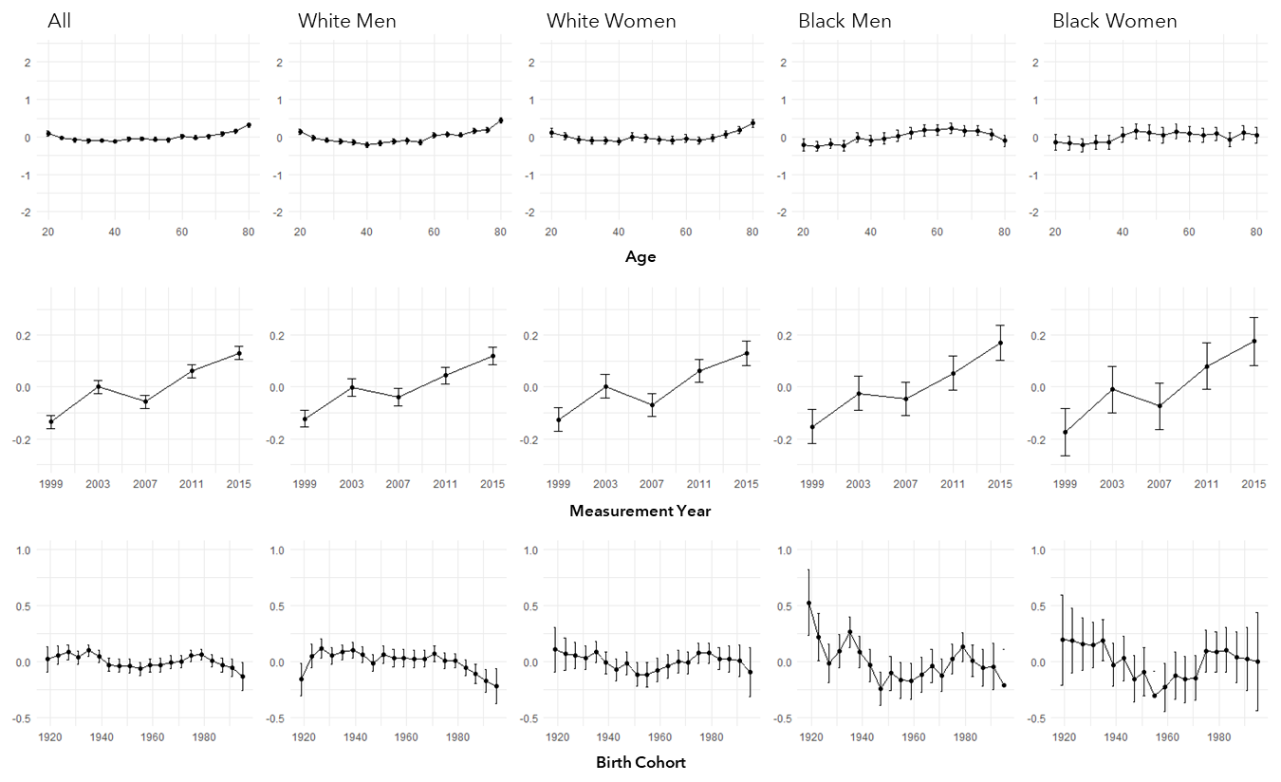

### **Supplemental Figure B2.** Median Polish approach to APC decomposition

The figure shows the independent effects of age, period, and cohort as estimated using the Median Polish (MP) estimator, both in the full sample and separately by race-sex strata. Survey weights were applied in estimating mean biological aging values for each cell in age-by-period contingency tables. Effect-sizes are denominated in standard-deviation (SD) units of biological-age advancement, and are interpretable as the estimated effects of age, period, and cohort on biological aging.

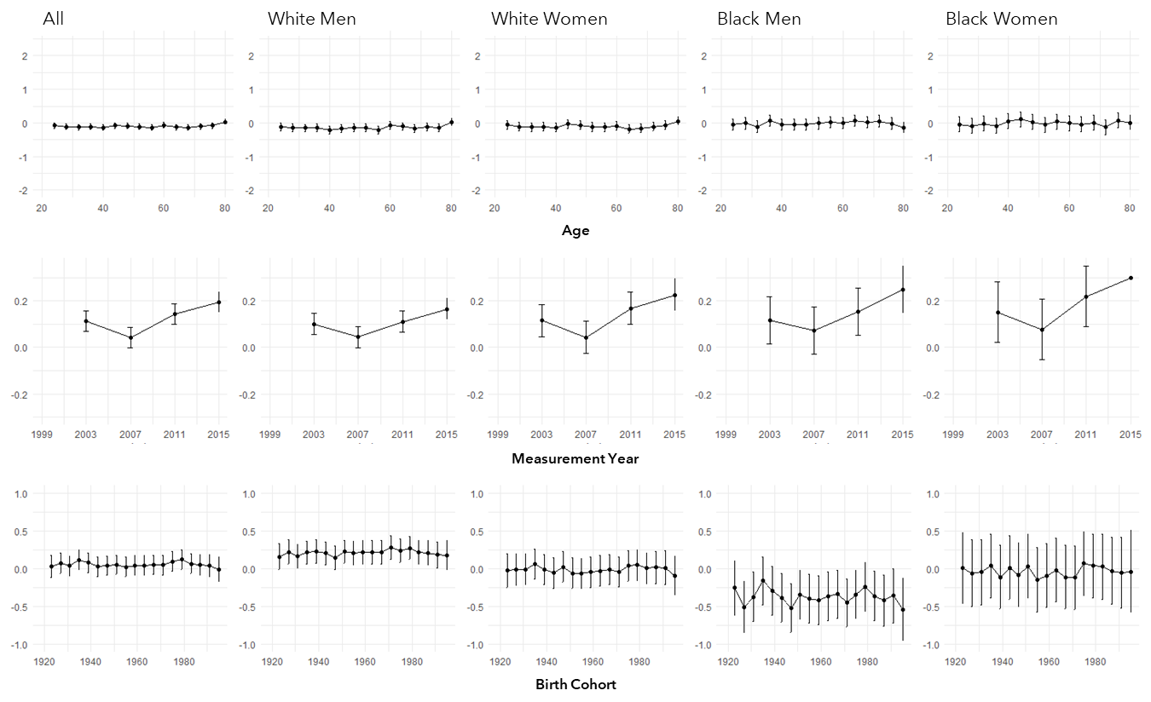

### **Supplemental Figure B3.** Bayesian Hierarchical Age-Period-Cohort models treating age as a factor variable

The figure shows the independent effects of age, period, and cohort as estimated using fully specified Bayesian Hierarchical Age-Period-Cohort (BHAPC) models with age treated as a factor rather than a continuous variable, both in the full sample and separately by race-sex strata. We treated age as a level-1 fixed effect and period and cohort as level-2 random effects; survey weights were log-transformed and included as a level-1 covariate while sampling strata and clusters were included as random effects. Effect-sizes are denominated in standard-deviation (SD) units of biological-age advancement, and are interpretable as the estimated effects of age, period, and cohort on biological aging.

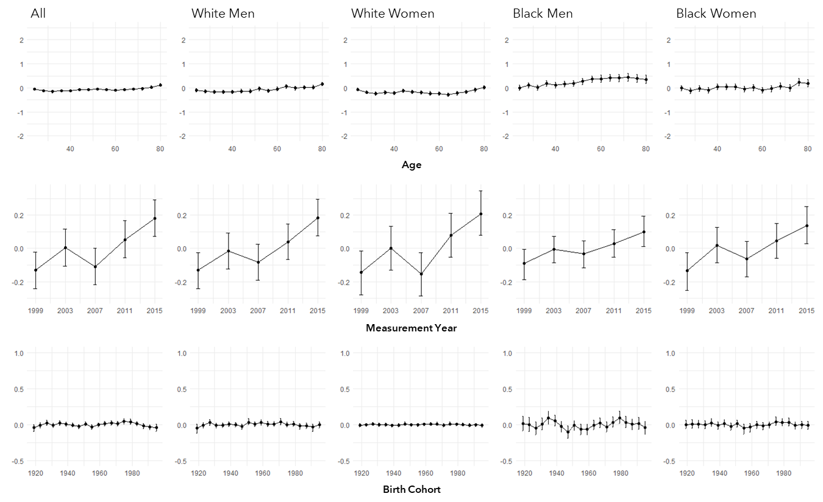

### **Supplemental Figure B4.** Bayesian Hierarchical Age-Period-Cohort models using Homeostatic Dysregulation measure of biological aging

The figure shows the independent effects of age, period, and cohort as estimated using fully specified Bayesian Hierarchical Age-Period-Cohort (BHAPC) models with Homeostatic Dysregulation as the biological aging outcome variable, both in the full sample and separately by race-sex strata. We treated age as a level-1 fixed effect and period and cohort as level-2 random effects; survey weights were log-transformed and included as a level-1 covariate while sampling strata and clusters were included as random effects. Effect-sizes are denominated in standard-deviation (SD) units of biological-age advancement, and are interpretable as the estimated effects of age, period, and cohort on biological aging.

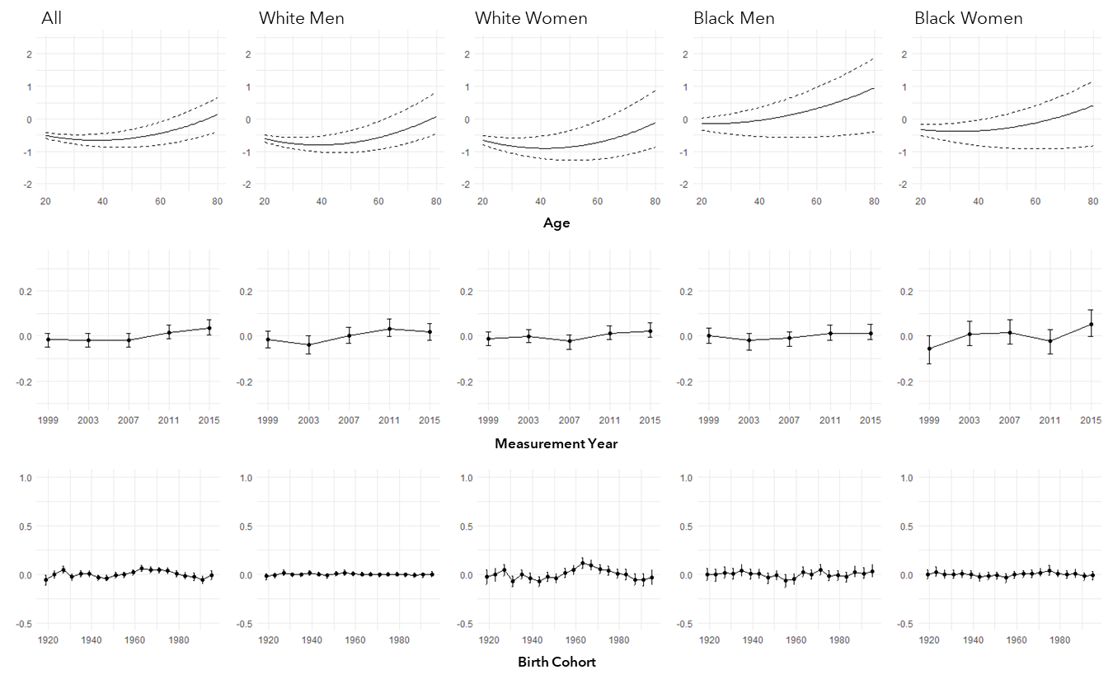

### **Supplemental Figure B5.** Bayesian Hierarchical Age-Period-Cohort models using PhenoAge-advancement measure based on original Levine biomarkers

The figure shows the independent effects of age, period, and cohort as estimated using fully specified Bayesian Hierarchical Age-Period-Cohort (BHAPC) models with PhenoAge (trained on original Levine biomarkers rather than our original biomarker set) as the biological aging outcome variable, both in the full sample and separately by race-sex strata. We treated age as a level-1 fixed effect and period and cohort as level-2 random effects; survey weights were log-transformed and included as a level-1 covariate while sampling strata and clusters were included as random effects. Effect-sizes are denominated in standard-deviation (SD) units of biological-age advancement, and are interpretable as the estimated effects of age, period, and cohort on biological aging.

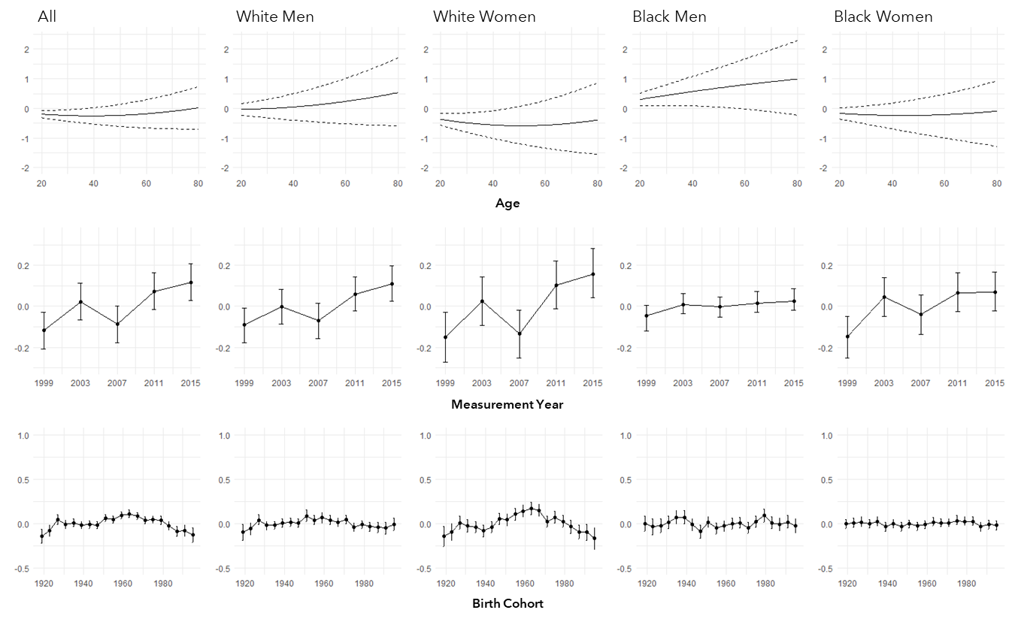

### **Supplemental Figure B6.** Bayesian Hierarchical Age-Period-Cohort models using PhenoAge-advancement measure calculated using the residualized-change score method

The figure shows the independent effects of age, period, and cohort as estimated using fully specified Bayesian Hierarchical Age-Period-Cohort (BHAPC) models with PhenoAge (calculated as residualized-change rather than difference-scores) as the biological aging outcome variable, both in the full sample and separately by race-sex strata. We treated age as a level-1 fixed effect and period and cohort as level-2 random effects; survey weights were log-transformed and included as a level-1 covariate while sampling strata and clusters were included as random effects. Effect-sizes are denominated in standard-deviation (SD) units of biological-age advancement, and are interpretable as the estimated effects of age, period, and cohort on biological aging.

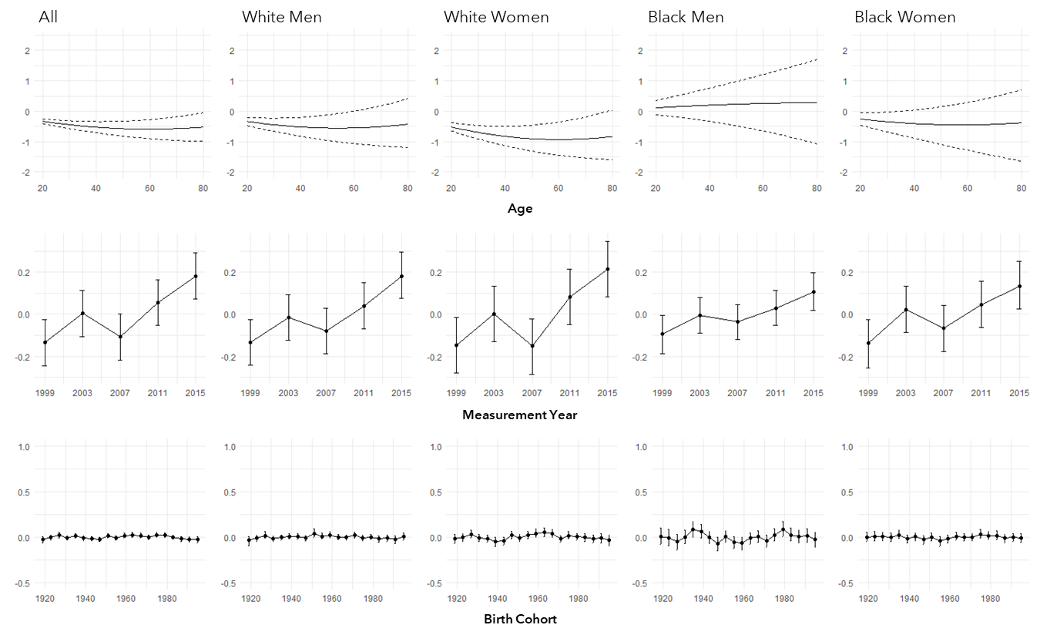

### **Supplemental Table B1.** Intrinsic Estimator approach to APC decomposition

The table shows the independent effects of age, period, and cohort as estimated using the Intrinsic Estimator (IE) method, both in the full sample and separately by race-sex strata. Survey weights were applied in estimating mean biological aging values for each cell in age-by-period contingency tables. Effect-sizes are denominated in standard-deviation (SD) units of biological-age advancement, and are interpretable as the estimated effects of age, period, and cohort on biological aging.



### **Supplemental Table B2.** Median Polish approach to APC decomposition

The table shows the independent effects of age, period, and cohort as estimated using the Median Polish (MP) estimator, both in the full sample and separately by race-sex strata. Survey weights were applied in estimating mean biological aging values for each cell in age-by-period contingency tables. Effect-sizes are denominated in standard-deviation (SD) units of biological-age advancement, and are interpretable as the estimated effects of age, period, and cohort on biological aging.



### **Supplemental Table B3.** Bayesian Hierarchical Age-Period-Cohort models treating age as a factor variable

The table shows the independent effects of age, period, and cohort as estimated using fully specified Bayesian Hierarchical Age-Period-Cohort (BHAPC) models with age treated as a factor rather than a continuous variable, both in the full sample and separately by race-sex strata. We treated age as a level-1 fixed effect and period and cohort as level-2 random effects; survey weights were log-transformed and included as a level-1 covariate while sampling strata and clusters were included as random effects. Effect-sizes are denominated in standard-deviation (SD) units of biological-age advancement, and are interpretable as the estimated effects of age, period, and cohort on biological aging.



### **Supplemental Table B4.** Bayesian Hierarchical Age-Period-Cohort models using Homeostatic Dysregulation measure of biological aging

The table shows the independent effects of age, period, and cohort as estimated using fully specified Bayesian Hierarchical Age-Period-Cohort (BHAPC) models with Homeostatic Dysregulation as the biological aging outcome variable, both in the full sample and separately by race-sex strata. We treated age as a level-1 fixed effect and period and cohort as level-2 random effects; survey weights were log-transformed and included as a level-1 covariate while sampling strata and clusters were included as random effects. Effect-sizes are denominated in standard-deviation (SD) units of biological-age advancement, and are interpretable as the estimated effects of age, period, and cohort on biological aging.



### **Supplemental Table B5.** Bayesian Hierarchical Age-Period-Cohort models using PhenoAge-advancement measure based on original Levine biomarkers

The table shows the independent effects of age, period, and cohort as estimated using fully specified Bayesian Hierarchical Age-Period-Cohort (BHAPC) models with PhenoAge (trained on original Levine biomarkers rather than our original biomarker set) as the biological aging outcome variable, both in the full sample and separately by race-sex strata. We treated age as a level-1 fixed effect and period and cohort as level-2 random effects; survey weights were log-transformed and included as a level-1 covariate while sampling strata and clusters were included as random effects. Effect-sizes are denominated in standard-deviation (SD) units of biological-age advancement, and are interpretable as the estimated effects of age, period, and cohort on biological aging.



### **Supplemental Table B6.** Bayesian Hierarchical Age-Period-Cohort models using PhenoAge-advancement measure calculated using the residualized-change score method

The table shows the independent effects of age, period, and cohort as estimated using fully specified Bayesian Hierarchical Age-Period-Cohort (BHAPC) models with PhenoAge (calculated as residualized-change rather than difference-scores) as the biological aging outcome variable, both in the full sample and separately by race-sex strata. We treated age as a level-1 fixed effect and period and cohort as level-2 random effects; survey weights were log-transformed and included as a level-1 covariate while sampling strata and clusters were included as random effects. Effect-sizes are denominated in standard-deviation (SD) units of biological-age advancement, and are interpretable as the estimated effects of age, period, and cohort on biological aging.



References

1. Kirkwood TB. Understanding the odd science of aging. Cell. 2005;120(4):437–47.

2. Kennedy BK, Berger SL, Brunet A, Campisi J, Cuervo AM, Epel ES, et al. Geroscience: linking aging to chronic disease. Cell. 2014;159(4):709–13.

3. Ferrucci L, Gonzalez‐Freire M, Fabbri E, Simonsick E, Tanaka T, Moore Z, et al. Measuring biological aging in humans: A quest. Aging Cell. 2020;19(2):e13080.

4. Belsky DW, Moffitt TE, Cohen AA, Corcoran DL, Levine ME, Prinz JA, et al. Eleven telomere, epigenetic clock, and biomarker-composite quantifications of biological aging: do they measure the same thing? American Journal of Epidemiology. 2018;187(6):1220–30.

5. Jylhävä J, Pedersen NL, Hägg S. Biological age predictors. EBioMedicine. 2017;21:29–36.

6. Jansen R, Han LK, Verhoeven JE, Aberg KA, van den Oord EC, Milaneschi Y, et al. An integrative study of five biological clocks in somatic and mental health. Elife. 2021;10:e59479.

7. Li X, Ploner A, Wang Y, Magnusson PK, Reynolds C, Finkel D, et al. Longitudinal trajectories, correlations and mortality associations of nine biological ages across 20-years follow-up. Elife. 2020;9:e51507.

8. Levine ME, Lu AT, Quach A, Chen BH, Assimes TL, Bandinelli S, et al. An epigenetic biomarker of aging for lifespan and healthspan. Aging (Albany NY). 2018;10(4):573.

9. Li Q, Wang S, Milot E, Bergeron P, Ferrucci L, Fried LP, et al. Homeostatic dysregulation proceeds in parallel in multiple physiological systems. Aging cell. 2015;14(6):1103–12.

10. Kwon D, Belsky DW. A toolkit for quantification of biological age from blood chemistry and organ function test data: BioAge. GeroScience. 2021;43(6):2795–808.

11. RStudio Team. RStudio: integrated development for R. 2015;